Coin Change Problem

Problem
Given a set of coins and a value V. Find the number of ways in which we can make change of V.

Example
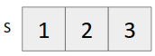
V = 3
Possible ways to make change are {3}, {2,1}, {1,1,1}.
Note: {1,2} is not counted as a separate way as it is same as {2,1}.

To make ways with every coin, we have 2 options
- Take it
- Do not take it

Recurrence relation
cnt(S[], m, V) = cnt(S[], m, V-Sm) + cnt(S[], m-1, V)
Since it can be represented as a Recurrence relation, hence it has Optimal Substructure Property.

To see overlapping subproblem property,
Let us take an example
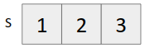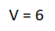

Making recursion tree

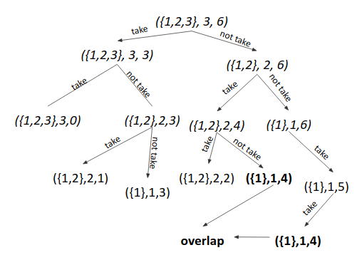

We can see ({1},1,4) has repeated. Hence it also has Overlapping Subproblem Property.

Since it follows both optimal substructure property and overlapping subproblem property, hence it can be solved using Dynamic Programming.

Approach 1 (Using Memoization)
- Write the recursive solution.
- Memoize it.

Approach 2 (Tabulation - Bottom Up)
- Take each coin one by one and fill the dp table till that coin, for all the values from 0 to V.

Example


Coin/Value | 0 | 1 | 2 | 3 | 4 | 5 | 6
# | 1 | 0 | 0 | 0 | 0 | 0 | 0
1 | 1 | 1 | 1 | 1 | 1 | 1 | 1
2 | 1 | 1 | 2 | 2 | 3 | 3 | 4
3 | 1 | 1 | 2 | 3 | 4 | 5 | 7

- For every cell, we have 2 options
  - Take that coin (dp[i][j-s[i-1])
  - Do not take that coin (dp[i-1][j])
Time Complexity: O(V*n)
Space Complexity: O(V*n).

Approach 3 (Tabulation with space efficiency)
- Just a minor change in approach 2.
- We knew for every cell, we have 2 options
  - Take that coin
  - Do not take that coin. (We do not take extra row. Update on the same cell).

Time Complexity: O(V*m)
Space Complexity: O(n).

Dry Run

When no coin was taken
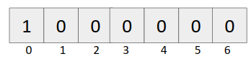

When {1} was taken
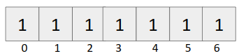

When {1,2} was taken
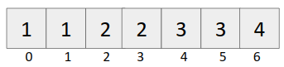

When {1,2,3} was taken
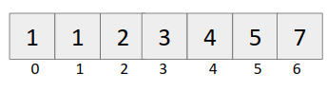

Code (Memoization)
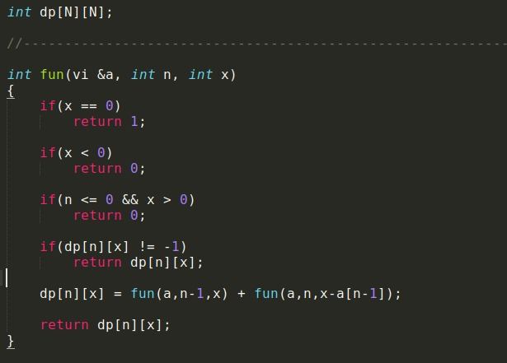
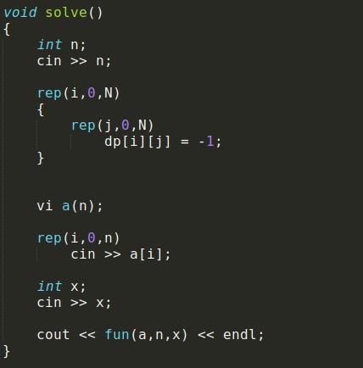
Code (Iterative)
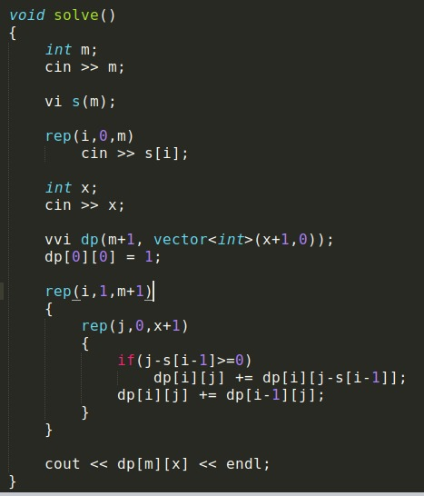

Code (Space optimization)
